In the Module 3 Assignment Instructions workflow, you carried out target preparation and validation tasks for 2OWB and 2RKU.

**Write 1-2 paragraphs detailing your observations, comparing and contrasting the structures.**

Think about the following as you formulate your answer:

* Which target appears to be “best” based on Protein Reliability metrics?
* If you used PrimeX (optional), did you make any interesting observations?
* After optimization, did you observe any tautomerization changes or residue flips in the binding pocket regions?
* Did the SiteMaps show good agreement with the ligand-binding site, and with each other? Did they meet the expected criteria in terms of SiteScore, DScore, volume, and balance?
* What did the WaterMap results tell you?
* If you had to choose just one, which structure would you take forward for structure-based virtual screening?

2RKU (https://onlinelibrary.wiley.com/doi/epdf/10.1111/j.1747-0285.2007.00594.x) is one of the polo-like kinase 1, is an important regulator of cell cycle progression whose over-expression is often associated with oncogenesis. That’s why PLK1 hence represents an attractive target for cancer intervention. BI 2536, has been shown to inhibit PLK isoforms (PLK1, PLK2, PLK3, PLK4) in vitro with low nanomolar potency and with high selectivity against a larger panel of kinases. 2RKU is the co-crystal structure of polo-like kinase 1 with BI 2536.

2OWB (chrome-extension://dagcmkpagjlhakfdhnbomgmjdpkdklff/enhanced-reader.html?openApp&pdf=https%3A%2F%2Fpubs.acs.org%2Fdoi%2Fpdf%2F10.1021%2Fbi602474j) is also one of the polo-like kinase 1. Polo-like kinase 1 (Plk1) is an attractive target for the development of anticancer agents due to its importance in regulating cell-cycle progression. Overexpression of Plk1 has been detected in a variety of cancers, and expression levels often correlate with poor prognosis. Despite high interest in Plk1-targeted therapeutics, there is currently no structure publicly available to guide structure-based drug design of specific inhibitors. 2OWB is the co-crystalized with the pyrrolo-pyrazole inhibitor PHA-680626.

Here we are going to validate two PLK1 proteins, i.e. 2OWB, 2RKU. First we prepare protein reliability report for both protein to visualize which properties need to fix by protein preparation wizard before analyzing binding sites in them. Initial reliability reports of both protein show that presence of ligand and structure quality in the binding sites are in great condition. But there are some structural issues in the full structure, between them 2OWB has the highest steric clashes. And there are some minor structural issues. To fix these issues, we prepare the protein with protein preparation wizard.

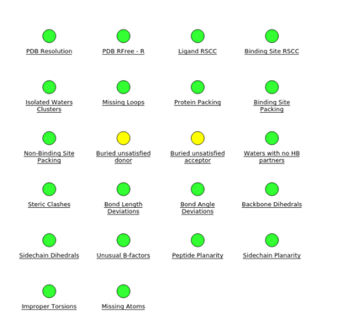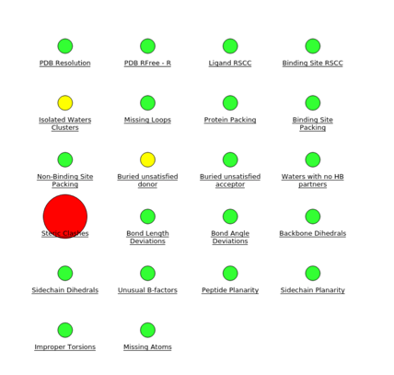

Figure 1: Protein reliability report of (left) 2RKU and (right) 2OWB before preparation

Viewing the electron density and looking at the fit can be useful, particularly in the binding site, side-chain orientations in binding site regions can drastically affect docking. Primex can be used to review the density and help make judgements about side chain orientation, particularly where alternate positions are presented. We also used Primex to choose better oriented side chains of both proteins. No alternative positions suggested for the residues are part of the binding pockets in the case of both proteins. But we did find that some positions are most likely than others according to the electron density around them and we commit them during protein preparation. Since suggested alternative positions are not at or near the binding pockets, we are not considering structure with the alternate positions.

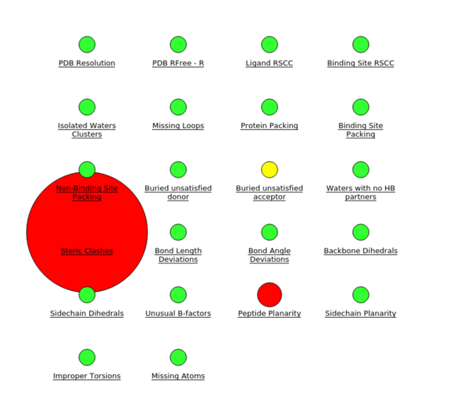 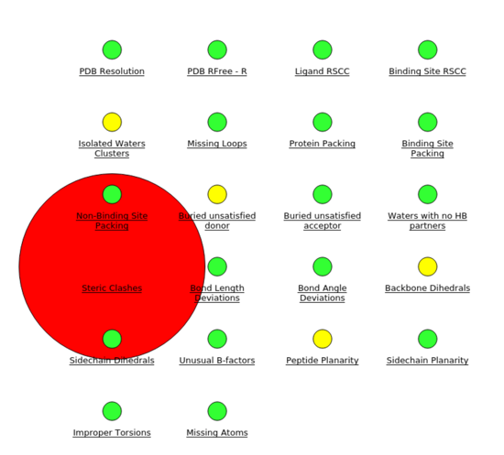

Figure 2: Protein reliability report of (left) 2RKU and (right) 2OWB after preparation

From the protein reliability report, 2RKU appears to be “best”. After optimization and minimization we observed that few residues of 2OWB flipped in binding pocket regions. Similar findings observed for 2RKU too.

In following section, we are going to explain the findings of our sitemap analysis:

For this project, the proteins we considered have co-crystalized ligands. So, we analyzed sitemap for apo (without ligands and water molecules) and holo (with ligands but without water molecules) proteins. We have used Maestro SiteMap tool to identify the potential binding sites and evaluate the existing one. We found several potential sites for 2OWB apo dry and 2RKU apo dry. We ranked them based on sitescore, dscore, balance, volume. For 2OWB, site score is greater than 1, which implies promising binding sites, which also nearly coincide with co-crystalized ligand position. Dscore of the site is also higher than 1, indicates the drugability of the site. Balance, expresses the ratio of hydrophobic and hydrophilic. The average balance score for tight-binding site is 1.6. For site 1 of 2OWB features 1.184, which indicates good-binding site for ligand. We got 1 good site for 2RKU, which shows greater than 1 sitescore, dscore and balance. The evaluated site of holo dry proteins nearly overlapped with apo proteins’ site 1.

i.e.: criteria of good binding site: SiteScore and Dscore should be greater than 1, balance should be greater 0.3 and volume 225

We analyze the watermap on both apo and holo protein of 2OWB. Result of apo protein shows co-crystallized ligand in its binding mode and naturally overlaps with water molecules. Very few of them are red spheres(, which indicates favorable energetics () for displacement of the water. On the other hand, watermap of holo protein shows no overlaps between ligand and red spheres of water. Overlapped visualization of watermap of holo protein and apo protein shows that, most of the spheres of both watermap overlap with each other, but not with the red spheres overlap with ligand in the apo protein. Which can indicate that the existing binding site has great affinity to be binding site of target.

We analyze the watermap on both apo and holo protein of 2RKU. Result of apo protein shows co-crystallized ligand in its binding mode and naturally overlaps with water molecules. Very few of them are red spheres(, which indicates favorable energetics () for displacement of the water. On the other hand, watermap of holo protein shows no overlaps between ligand and red spheres of water. Overlapped visualization of watermap of holo protein and apo protein shows that, most of the spheres of both watermap overlap with each other, but not with the red spheres overlap with ligand in the apo protein. Which can indicate that the existing binding site has great affinity to be binding site of target.

From the discussion above, in some cases 2OWB appears to be better but not with higher degree. On the other hand 2RKU has higher resolution than 2OWB. So. We think, we will choose 2RKU for the structure-based virtual screening.